Individual Pathways
Activity 6.2
Investigating the atom
- Insert a word to complete each sentence.
- John Dalton proposed that all matter consisted of tiny particles called................................
- J.J.Thomson proposed that atoms consisted of a ......................... sphere containing negatively charged electrons.
- Rutherford's alpha particle experiments revealed that atoms contained a central positive .............
- The nucleus of the atom contains protons and...............................
- Bohr proposed that ............................ were located in fixed energy shells around the nucleus.

- The following apparatus was used by Rutherford to investigate the structure of the atom.

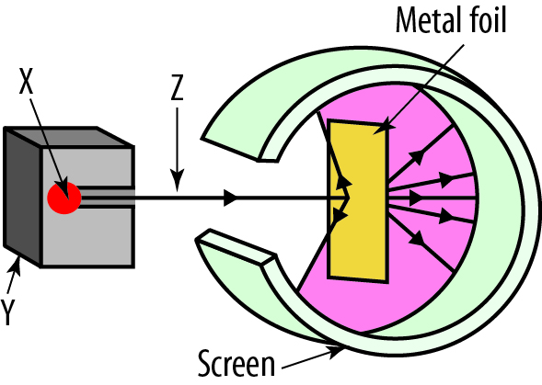

- Identify which of the following elements could be a source (X) of radiation: hydrogen, lead, gold, radium, carbon.
..................................................................

- X is protected by a box Y. Which of the following is a suitable material for box Y: carbon, gold, lead, copper.
................................................................

- Identify the radiation labelled Z: ............................................
- Most of the radiation strikes the screen without deflection. What does this imply about the atom?
..................................................................................................................................................................................................................................................................................................................
- Explain why some radiation is deflected backwards at great angles.
..................................................................................................................................................................................................................................................................................................................

- Complete the following table. You may need to refer to the periodic table.

Element | Symbol | Number of protons | Number of neutrons | Number of electrons
Fluorine | F
Potassium |  | 19 | 21
 | 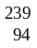Pu
Krypton |  | 36 | 56
 | 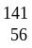Ba

- The model of the atom produced by Niels Bohr had electrons arranged in energy levels or shells at different radial distances from the nucleus. The first shell (n =1; closest to the nucleus) was called the K shell. The table shows the shell number and name. Given that the maximum number of electrons in each shell ‘n’ is 2n², complete the table. The first row has been completed for you.

Shell number  (n) | Shell letter | Maximum electron number
1 | K | 2(1)² = 2
2 | L
3 | M
4 | N
5 | O

- Each chemical element has a different number of protons and electrons. Electrons fill the electron shells starting from the K shell and working outwards. Once a shell is filled, any remaining electrons start to fill the next shell. Thus beryllium (Be) has four electrons and the first two electrons fill the K shell. The remaining two electrons are placed in the L shell.
Based on this information, complete the following table.
Element | Z | K shell | L shell | M shell
Carbon | 6
Sodium | 11
Silicon | 14
Chlorine | 17

- The following diagram shows the nuclei of various atoms. Each circle represents a proton or a neutron. In each example, shade in the neutrons that are present.
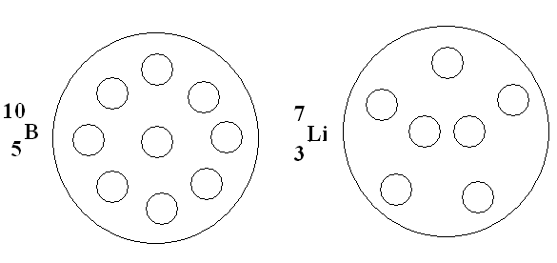
- Lead-211 has a half-life of 36 minutes. A 50 g sample of Pb-211 was obtained and the mass remaining measured as a function of time. Construct a line graph of the mass of lead-211 remaining after six half-lives have elapsed.

- The following graph shows the decay curve for oxygen-15.
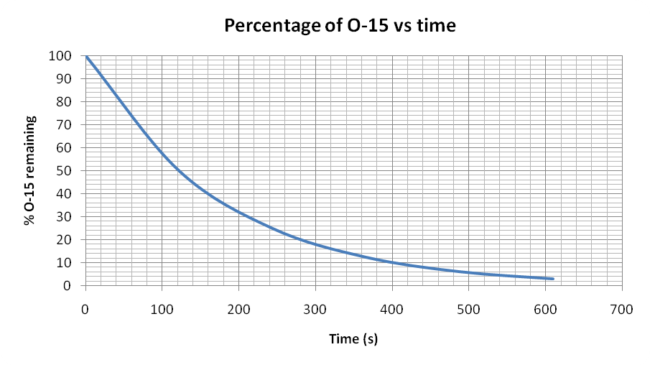
Using the graph, estimate the half-life of oxygen-15. ................................................................

- Bismuth-210 (Z=83) radioactively decays to form polonium-210 (Z= 84).
- Calculate the number of protons and neutrons in the bismuth-210 isotope.
.......................................................................................................................................................
- Calculate the number of protons and neutrons in the polonium-210 isotope.
.......................................................................................................................................................
- Explain what has happened during this nuclear decay.
......................................................................................................................................................

- In the natural decay of U-238 (Z=92), the daughter nucleus formed is Th-234 (Z= 90). Determine the type of radiation emitted.
.............................................................................................................................................................

Answers

- John Dalton proposed that all matter consisted of tiny particles called atoms.
- J.J.Thomson proposed that atoms consisted of a positive sphere containing negatively charged electrons.
- Rutherford's alpha particle experiments revealed that atoms contained a central positive nucleus.
- The nucleus of the atom contains protons and neutrons.
- Bohr proposed that electrons were located in fixed energy shells around the nucleus.

- X = radium
- Y = lead
- Z = alpha particles
- The atom is largely empty space
- Some of the alpha particles are on (or almost on) target for the tiny positive nucleus. They are deflected backwards by electrostatic repulsion.

3.
Element | Symbol | Number of protons | Number of neutrons | Number of electrons
Fluorine | F | 9 | 10 | 9
Potassium | K | 19 | 21 | 19
Plutonium | Pu | 94 | 145 | 94
Krypton | Kr | 36 | 56 | 36
Barium | Ba | 56 | 85 | 56

4.
Shell number  (n) | Shell letter | Maximum electron number
1 | K | 2(1)² = 2
2 | L | 2(2)² = 8
3 | M | 2(3)² = 18
4 | N | 2(4)² = 32
5 | O | 2(5)² = 50

5.
Element | Z | K shell | L shell | M shell
Carbon | 6 | 2 | 4
Sodium | 11 | 2 | 8 | 1
Silicon | 14 | 2 | 8 | 4
Chlorine | 17 | 2 | 8 | 7

6.
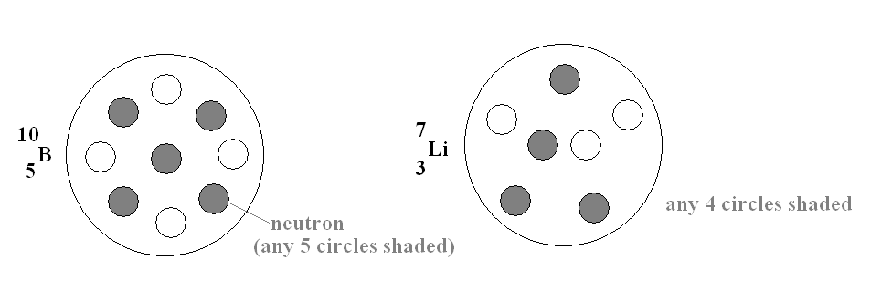
7.
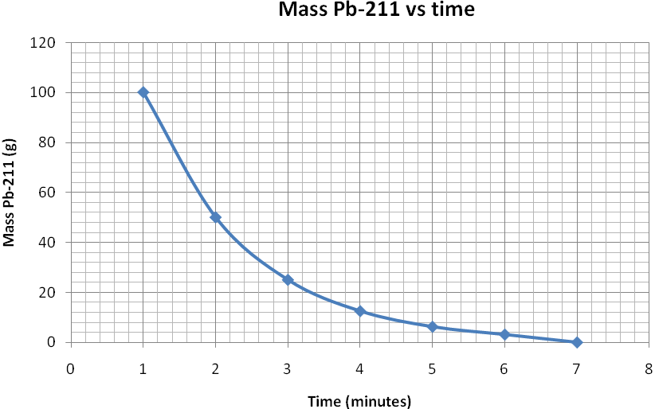

- Half-life = 120 seconds

- p = 83
n = 210 − 83 = 127
- p = 84
n = 126
- One neutron has decayed and a proton has formed. To maintain a charge balance, a beta particle must also have formed and been ejected as radiation.

- U-238 has 92 protons and 146 neutrons. Th-234 has 90 protons and 144 neutrons. Thus the radiation released has 2 protons and 2 neutrons. This is an alpha particle.

